

Volunteer Handbook

Thursday 13th August 2026

Dear Volunteer,

Thank you so much for donating your time and energy to support our young people on such an important day - we would not be able to do this without you.

The aim of this handbook and the accompanying training video is to help prepare you for your volunteering and to outline the valuable support and motivation you’ll be able to offer the young people you assist.

We hope that you have a really positive experience and we know from previous years (we’ve been doing this since 2013) that volunteer support is greatly appreciated by both students and our partner schools.

Thank you and if you have any further questions please don’t hesitate to get in touch.

Best wishes,


Laura Littlehales

Introduction 6
Aims of the day 7
How do we achieve these aims? 7
Results Day Overview 8
Key UCAS and Clearing information for 2026 9
UCAS 9
UCAS Hub 9
University offers 9
Confirmation 10
Clearing 11
Key Clearing dates for 2026 12
Who can use Clearing? 12
Adding a Clearing choice 12
Clearing Plus 13
Important warning: declining a place 13
How best to support students on the day 14
1. Understand the student’s situation 14
2. Listen first 14
3. Agree a plan with the student 15
4. Help students prepare for calls 15
Suggested university call script 16
5. Debrief after each call 16
6. Record actions 17
7. Agree next steps 17
8. Record the number of students supported 18
Safeguarding, boundaries and data protection 18
Safeguarding 18
Boundaries 19
Data protection 19
Scenario 1: The student has missed the required grades for both university choices 20
Volunteer approach 20
Important 20
Scenario 2: The student has achieved higher grades than expected 21
Volunteer approach 21
Important 21
Scenario 3: The student missed their firm choice but met their insurance choice 21
Volunteer approach 22
Volunteer approach 22
Scenario 5: The student wants to appeal their results 22
Volunteer approach 23
Scenario 6: The student has not met their offers and wants to apply for an apprenticeship 23
Volunteer approach 23
Scenario 7: The student does not want to go to university 24
Volunteer approach 24
Scenario 8: The student is very upset or overwhelmed 24
Volunteer approach 25
9. FAQs 25
What if the student’s UCAS application has not been updated? 25
What if the UCAS Hub is busy or slow? 26
What if a student asks whether they should decline their place? 26
What if a student asks about student finance? 27
What if a student has not yet applied for student finance? 27
What if a student asks about accommodation? 28
What if a student wants to study Medicine or Dentistry? 28
What if a student wants to study Law? 28
What if a student asks about foundation years? 29
What if a student asks about resits? 29
Important Contact Details and Website Links 29
UCAS contacts 30
Student Finance England 30
Useful website links 30
Appendix 32
Different types of qualifications 32
GCSEs 32
A levels and AS levels 32
International Baccalaureate 32
BTECs 32
T Levels 33
Apprenticeship levels 33
Intermediate apprenticeships — Level 2 33
Advanced apprenticeships — Level 3 33
Higher apprenticeships — Level 4+ 34
Degree apprenticeships — Levels 5 to 7 34
Important apprenticeship guidance 34
UCAS Tariff points 35
Common UCAS Tariff points 35
Final volunteer reminders 37

Introduction

MyBigCareer starts working with students from around 12 years old and follows them through their secondary school journey.
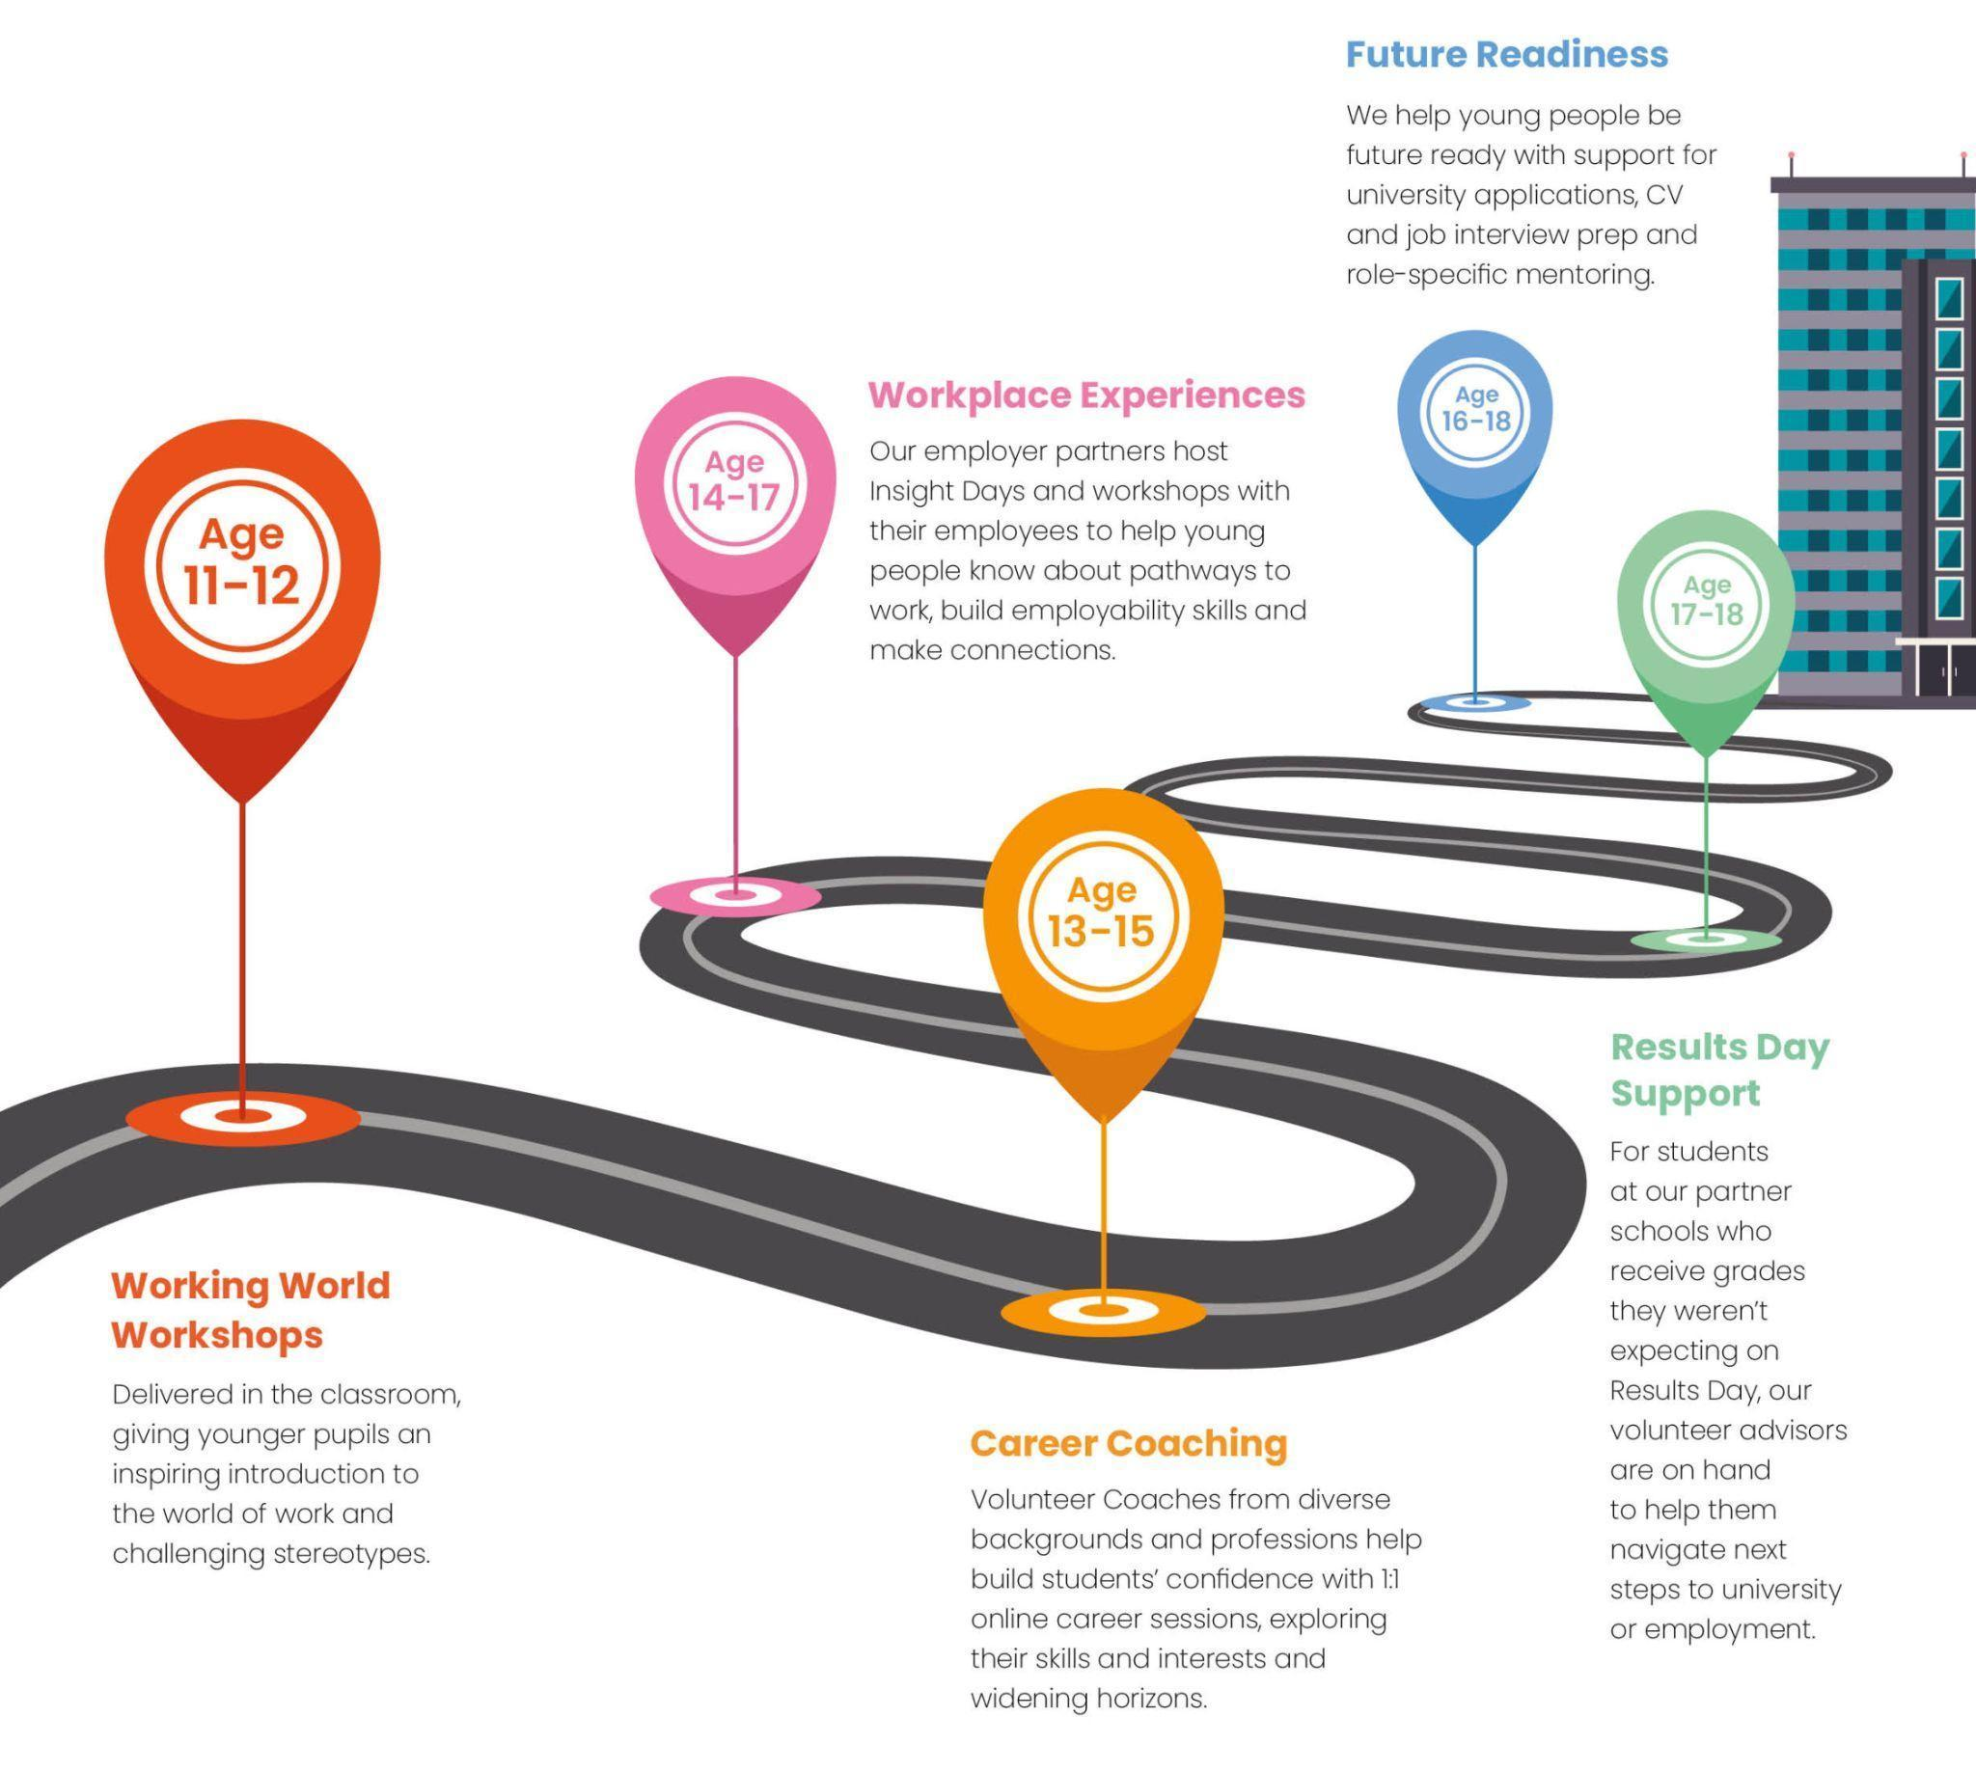
There is probably no single day more important than the day many 18-year-olds find out their Level 3 exam results. In 2026, A level / JCQ Results Day is Thursday 13 August 2026.
This is the day many students will confirm their next steps, whether that is going to university, applying for apprenticeships, considering employment, taking a gap year, resitting exams, or exploring other pathways.
Results Day can feel intimidating. Students may be excited, relieved, disappointed, anxious or overwhelmed. They may need practical help, but they may also need calm encouragement and reassurance.
As a volunteer, your role is not to make decisions for students. Your role is to help them understand their options, stay calm, ask useful questions, take practical next steps and know where to get further support.

Aims of the day
The aims of the day are context-based and will depend on the school setting and the students you meet. They may include:
- celebrating student achievements;
- supporting students with decision-making;
- reassuring students that they have options available;
- signposting students towards further sources of support and guidance;
- supporting school staff where appropriate;
- helping students devise an action plan for the day and beyond;
- helping students build confidence to take next steps, such as calling universities;
- keeping appropriate records so that MyBigCareer and/or the school can offer ongoing support;
- fulfilling our safeguarding responsibilities.

How do we achieve these aims?
Volunteers should:
- complete all assigned reading and training provided by MyBigCareer;
- listen without judgement;
- ask open and supportive questions;
- remain calm and friendly;
- take a positive and solution-focused approach;
- be organised;
- know when to refer a question to school staff or MyBigCareer;
- follow safeguarding and data protection guidance at all times.

Results Day Overview
This section explains the relevant parts of the UK education system and the options available to students on Results Day.
Please remember that you are not expected to know everything. On the day, you will also have support from the school team and MyBigCareer contacts. If you are unsure, ask.
School staff will be busy, but they remain the lead professionals in the school setting. Volunteers should work alongside them and follow school instructions.

Visit: The article on 'What your application status means' of the UCAS Hub offers a clear and simple explanation of the options available to students once they have been awarded their results.

Read: 'What to do on Results Day' has lots of useful information about Results Day.

Key UCAS and Clearing information for 2026

UCAS
UCAS is the organisation that coordinates most undergraduate university applications in the UK.
Most students you meet who are applying to university will already have applied through UCAS using predicted grades. Students will have selected university/course choices and may be holding a firm and/or insurance offer.
Students access their application through UCAS Hub. Each student has their own login details and UCAS Personal ID. They should have these ready on Results Day.

UCAS Hub
Students should use UCAS Hub to check whether their university place has been confirmed.
UCAS Hub usually updates before students receive their results from school. However, UCAS Hub does not show exam grades. Students still need to collect or receive their official results from school or college.

University offers
University offers are usually either:
- Unconditional — the student has already met the requirements and has a confirmed place.
- Conditional — the student’s place depends on achieving specified grades or other conditions.
Most applicants will have selected:
- a firm choice — their preferred university/course;
- an insurance choice — a backup option, usually with lower or different conditions.
If the student meets the conditions of their firm choice, their place should usually be confirmed.
If they do not meet the conditions of their firm choice but meet the conditions of their insurance choice, their insurance place may be confirmed.
If they do not meet the conditions of either offer, or if they are not holding an offer, they may be eligible for Clearing.

Confirmation
Confirmation is the process where universities and colleges check whether students have met the conditions of their offers.
A student may see one of several outcomes in UCAS Hub, for example:
- their place is confirmed;
- they are accepted by their insurance choice;
- they are in Clearing;
- their application is still being considered;
- they need to contact the university or college.
If the student is unsure what their status means, encourage them to speak to school staff, check UCAS guidance, or contact the university directly.

Research: You can see the University League Tables here. To filter the best university by course, you’ll find the option to filter the ‘Subject League Tables’ at the top of the screen:
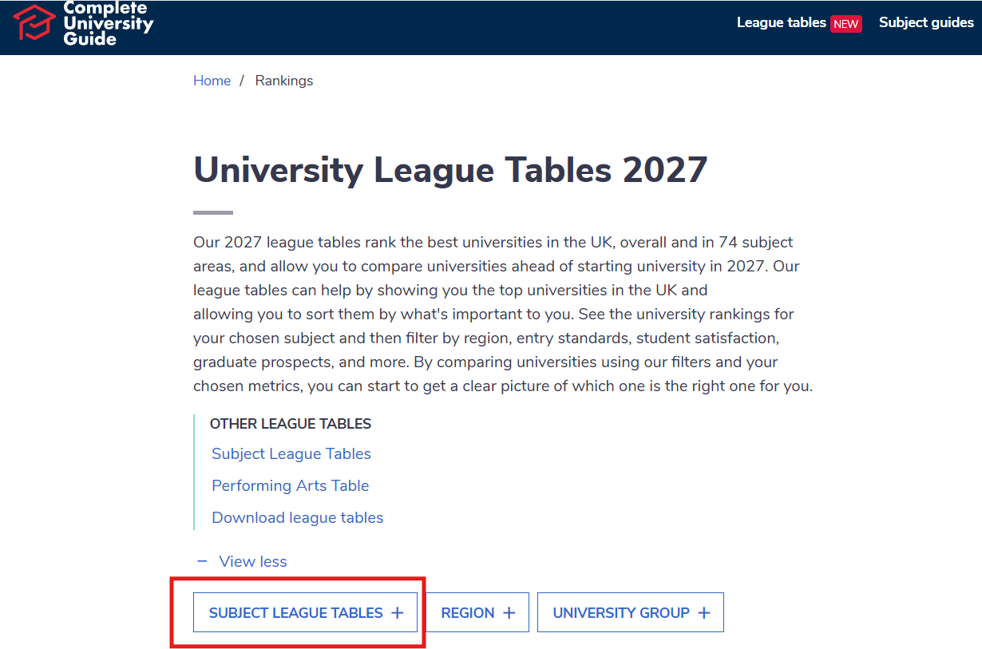

Clearing

Clearing is how universities and colleges fill places they still have available on their courses.
It is mainly used by students who:
- did not meet the conditions of their offers;
- are not holding any offers;
- declined offers;
- applied late;
- have changed their mind;
- have done better than expected and want to consider other options.

Key Clearing dates for 2026
- 2 July 2026 — Clearing opens.
- Thursday 13 August 2026 — A level / JCQ Results Day.
- 13:00 on Thursday 13 August 2026 — eligible applicants can add a Clearing choice in UCAS.
- 19 October 2026 — last date to add a 2026 Clearing choice.
- 21 October 2026 — final date for universities/colleges to make decisions on 2026 applications.

Who can use Clearing?
Students may be able to use Clearing if:
- they are applying after 30 June 2026;
- they did not receive any offers;
- they declined their offers;
- they did not meet the conditions of their firm or insurance offer;
- they are not holding a confirmed place;
- they have paid the appropriate UCAS application fee;
- they’ve declined their Firm place using the ‘Decline my place’ button in their application.
Students should not decline a confirmed place unless they understand the risk and have considered their options carefully. Clearing can move quickly on Results Day. Course availability may change throughout the day, and universities may update their own websites before UCAS listings are fully refreshed. Students should check UCAS, individual university websites, and contact universities directly where appropriate.

Adding a Clearing choice
Students can contact universities before adding a Clearing choice in UCAS. This is important because a student should normally speak to a university first and receive some indication that they may be offered a place before adding that choice in UCAS.
On A level Results Day, eligible students can usually add a Clearing choice from 13:00.

Clearing Plus
Clearing Plus is a UCAS service that may suggest courses to students based on their application and circumstances. Students can use it to explore options, but they should still research courses carefully and contact universities directly where appropriate.

Important warning: declining a place
Students should not use “Decline my place” or release themselves into Clearing unless they are sure they no longer want their confirmed place and understand that there is no guarantee they will secure another place.
If a student is unsure, pause and ask school staff or a MyBigCareer lead for support.
This page of the UCAS Hub has a lot of useful information and this video is helpful but please ignore the specific dates mentioned, as they are referring to a previous year. You can also watch this video which offers advice to students about clearing and what to do.
READ: This page has lots of useful information and FAQs about the Clearing process. For more useful information on confirmation of spaces and clearing, please visit this link.

How best to support students on the day
There are a few key steps to follow when assisting students.

1. Understand the student’s situation
Where possible, the student (or you on their behalf) should have completed an information or registration form. This may include:
- their name and contact details;
- school/college;
- results;
- university choices;
- current UCAS status;
- preferred next steps;
- any immediate concerns;
- whether they would like follow-up support.
Use this information to understand the student’s position. Do not assume that university is the right or preferred route for every student.

2. Listen first
Students may be emotional. Before jumping into solutions, give them space to explain what has happened and how they feel.
Useful opening questions include:
- “How are you feeling about your results?”
- “What were you hoping would happen today?”
- “What does UCAS Hub currently say?”
- “What options are you considering?”
- “What would a good next step look like for you?”

3. Agree a plan with the student
Discuss options with the student and agree what they would like to do next.
For university/Clearing support, this may include:
- checking their UCAS status;
- listing possible courses;
- comparing entry requirements;
- calling universities;
- preparing questions;
- writing down offers or next steps;
- agreeing what they will do after they leave school.
For non-university options, this may include:
- researching apprenticeships;
- looking at degree apprenticeships;
- considering employment options;
- speaking to school careers staff;
- exploring a gap year;
- planning resits or further study;
- arranging follow-up support.

4. Help students prepare for calls
If a student needs to call a university, help them prepare first. They should have:
- UCAS Personal ID;
- Clearing number, if eligible;
- full results;
- course name and course code, if available;
- phone number and email address;
- personal statement notes or relevant achievements (if they don’t have it to hand then it’s not a problem, try and have them remember as much as possible from their statement);
- questions they want to ask;
- paper or device for taking notes.
Students should normally make the call themselves. Volunteers can help them prepare and may sit with them if appropriate, but should not take over unless there is a clear reason and the student consents.

Suggested university call script
“Hello, my name is [student name]. I received my results today and I’m interested in [course name]. My grades are [grades]. I’d like to ask whether you have places available through Clearing and whether I could be considered.”
Useful follow-up questions include:
- “Would my grades meet your current Clearing requirements?”
- “Is there anything else you need from me?”
- “Would I need to attend an interview?”
- “Can you confirm the offer by email?”
- “How long do I have to make a decision?”
- “What accommodation options are available?”
- “Are there any bursaries or scholarships I could apply for?”
- “Can I visit the university or speak to someone from the course team?”

5. Debrief after each call
After each call, ask:
- What did the university say?
- Did they offer a place?
- Is the offer confirmed in writing?
- Is there a deadline?
- Does the student need to send documents?
- How does the student feel about this option?
- What is the next step?

6. Record actions
Please record actions on the student record/registration form or approved MyBigCareer system in as much detail as possible. This helps the school and/or MyBigCareer provide further support.
Record:
- student name;
- results, where appropriate;
- UCAS status, where relevant;
- courses/universities contacted;
- names of people spoken to, if known;
- offers made;
- deadlines;
- follow-up actions;
- any safeguarding or wellbeing concerns reported to school/MyBigCareer leads.

7. Agree next steps
In many cases, a student’s final destination will not be fully resolved on Results Day. Help the student leave with a simple action plan.
For example:
- “Call University A back by 3pm.”
- “Check email for confirmation.”
- “Speak to parent/guardian before making final choice.”
- “Do not decline current place until alternative is confirmed.”
- “Meet school careers adviser tomorrow.”
- “Apply for student finance/update details once place is confirmed.”
- “Contact MyBigCareer for follow-up support.”

8. Record the number of students supported
Results Day can be fast-paced, but please make a note of how many students you support.
Even if you only have a brief conversation and do not collect names or details, please record the number of students you spoke to. This helps MyBigCareer report accurately on the support provided.

Safeguarding, boundaries and data protection

Safeguarding
Volunteers have a responsibility to act if they are worried about a student’s safety or wellbeing.
If a student says something that makes you concerned about their safety, wellbeing, mental health, home situation or risk of harm:
- Stay calm.
- Listen.
- Do not promise confidentiality.
- Make a factual note of what was said.
- Report it immediately to the school safeguarding lead and the MyBigCareer safeguarding contact.
- Follow the school’s safeguarding process.
You do not need to investigate or solve the issue. Your responsibility is to pass the concern to the appropriate safeguarding lead.

Boundaries
Volunteers must not:
- be alone with a student in a private or hidden space;
- arrange to meet a student outside the event;
- share personal phone numbers, email addresses or social media details with students;
- continue private contact with students after the event;
- make decisions on behalf of students;
- pressure students towards a particular university, apprenticeship, employer or route;
- give financial, legal, immigration or mental health advice;
- store student personal data on personal devices;
- take photographs of students or forms unless specifically instructed through an approved MyBigCareer process.
Conversations should take place in open, visible areas agreed with the school.

Data protection
We require students to provide some personal information before we can offer direct support or follow-up.
Please only collect the information requested on the approved MyBigCareer student record/registration form.
Completed forms must be returned using the secure process confirmed in your volunteer briefing.
Do not keep copies, photos or notes containing student personal information on your personal device after they have been submitted.
If you are unsure how to record or submit information securely, contact the MyBigCareer on-the-day lead before collecting further details.
Secure registration / record form: Link is here
Completed records must be submitted using this form/process, or with physical copies which can be printed from here.

Common Results Day scenarios

Scenario 1: The student has missed the required grades for both university choices
The student may be eligible for Clearing.

Volunteer approach
- Sympathise with the student. They may be upset or emotional.
- Reassure them that they still have options.
- Check what UCAS Hub says.
- Help them identify courses available through Clearing.
- Encourage them to consider what matters to them: course, location, entry requirements, support, accommodation, future career, cost and wellbeing.
- Help them prepare to call universities.
- Encourage them to secure written confirmation of any offer.
- Record all actions and deadlines.

Important
Some universities may need students to send official documents before they can be formally accepted. Some courses may require an interview or additional assessment.
Students should not add a Clearing choice in UCAS until they understand the offer and have decided they want that option.

Scenario 2: The student has achieved higher grades than expected
The student may be happy with their confirmed place, or they may want to explore other options.

Volunteer approach
- Congratulate the student.
- Ask whether they are happy with their confirmed place.
- If they are happy, reassure them that they do not need to change anything.
- If they want to explore alternatives, help them research carefully.
- They should contact universities before declining any confirmed place.
- Remind them that using “Decline my place” carries risk.

Important
Students should not decline their confirmed place simply because they exceeded their offer. They should only consider this if they genuinely want a different course or university and understand the risks.

Scenario 3: The student missed their firm choice but met their insurance choice
UCAS may show that the student has been accepted by their insurance choice.

Volunteer approach
- Ask how the student feels about their insurance choice.
- If they are happy with it, reassure them.
- If they are unsure, help them think through the pros and cons.
- If they want to consider alternatives, help them research Clearing options.
- They should not decline their place unless they have considered the risks and ideally have an alternative offer confirmed.

Scenario 4: The student has been accepted by their insurance choice but does not want to go there
Sometimes students have not seriously imagined attending their insurance choice and may want to look elsewhere.

Volunteer approach
- Ask why they do not want to accept the insurance choice.
- Ask what a better option would look like.
- Help them research Clearing options.
- Encourage them to call universities before taking action in UCAS.
- Make sure they understand that declining a confirmed place can be risky.
- Refer to school staff or MyBigCareer if the student is uncertain.

Scenario 5: The student wants to appeal their results
Students may be able to appeal results, but this is a formal process led by the school or college.

Volunteer approach
- Acknowledge their feelings.
- Encourage them to speak to school staff immediately about the appeals process.
- Do not advise on the likelihood of success.
- Help them make a backup plan in case the appeal is unsuccessful.
- Encourage them to keep deadlines in mind.
Useful question:
“If the appeal is unsuccessful, what would you like your backup plan to be?”

Scenario 6: The student has not met their offers and wants to apply for an apprenticeship
Some students may decide that an apprenticeship or degree apprenticeship is a better route than university.

Volunteer approach
- Support the student’s thinking without pushing them towards university.
- Recognise that they may be emotional and may change their mind later.
- Encourage them to keep options open where possible.
- Explain that apprenticeships can be very competitive and often require time to research and apply.
- Help them identify employers, sectors or apprenticeship levels they are interested in.
- Encourage them to speak to school careers staff.
- If appropriate, help them consider whether securing a university place through Clearing could remain a backup while they explore apprenticeships.

Scenario 7: The student does not want to go to university
Not every student wants to go to university. Some may be considering employment, apprenticeships, a gap year, resits, further study or another route.

Volunteer approach
- Listen without judgement.
- Ask what they are hoping to do next.
- Help them identify practical next steps.
- Encourage them to speak to school careers staff.
- Signpost to appropriate resources.
- Help them leave with a short action plan.
Example action plan:
- “Speak to the school careers lead today.”
- “Research three apprenticeship vacancies this week.”
- “Update CV by Friday.”
- “Book a follow-up support session.”
- “Discuss options with parent/carer.”

Scenario 8: The student is very upset or overwhelmed
Results Day can be emotionally intense.

Volunteer approach
- Stay calm.
- Give the student time and space.
- Use reassuring language.
- Avoid rushing them into decisions.
- Encourage them to breathe, pause and take one step at a time.
- If you are concerned about their wellbeing, speak to school staff or the safeguarding lead.
Useful phrases:
- “You do not have to solve everything in the next five minutes.”
- “Let’s take this one step at a time.”
- “You still have options.”
- “Let’s work out the next practical thing you can do.”
- “Would you like to speak to a member of school staff before we go further?”

9. FAQs

What if the student’s UCAS application has not been updated?
If a student logs into UCAS Hub and their application has not updated, it may mean a university is still considering whether to accept them.
This can happen when a student has narrowly missed the grades for their firm or insurance choice.
Encourage the student to contact the university directly. They should have:
- UCAS Personal ID;
- course name;
- results;
- offer details;
- personal statement notes;
- questions they want to ask.
The aim is to calmly ask whether they are still being considered, whether the university needs any further information, and when they can expect a decision.
Volunteers should help students prepare, but students should normally speak for themselves.

What if the UCAS Hub is busy or slow?
UCAS Hub may be very busy on Results Day.
Encourage the student to:
- refresh carefully;
- log out and back in if needed;
- check their internet connection;
- avoid panic;
- speak to school staff if they are unsure;
- contact UCAS or the university if needed.

What if a student asks whether they should decline their place?
Do not tell a student to decline their place. They should only be doing this if they’ve secured a place through clearing at another university that they want to attend, or if they’ve decided that university is no longer the route for them.
Instead, help them think through:
- whether they are sure they do not want the place;
- whether they have another confirmed offer;
- whether they understand the risk;
- whether they need to speak to a parent/carer, school staff or UCAS;
- whether they need more time.
Suggested wording:
“I can help you think through the options, but I cannot make that decision for you. Before you decline a confirmed place, let’s make sure you understand what happens next and whether you have another option confirmed.”

What if a student asks about student finance?
Students may be concerned that changing universities through Clearing will affect their student finance.
Reassure them that this is common and that they should update their student finance details once their new university place is confirmed.
Volunteers should not give detailed financial advice. Signpost students to Student Finance England, school staff, parent/carer support or the university finance/support team. You can find out more about the Student Finance application process here.
Student Finance England: 0300 100 0607

What if a student has not yet applied for student finance?
If a student is planning to go to university in September and has not yet applied for student finance, encourage them to start as soon as possible.
Signpost them to Student Finance England and encourage them to speak to school staff or their parent/carer if they need help.

What if a student asks about accommodation?
If a student changes university through Clearing, they should ask the university about accommodation as soon as possible.
Questions they could ask:
- “Is accommodation still available?”
- “Are Clearing students eligible for halls?”
- “Is accommodation guaranteed?”
- “When is the accommodation deadline?”
- “What support is available if halls are full?”

What if a student wants to study Medicine or Dentistry?
Medicine and Dentistry places in Clearing are very limited and highly competitive.
Encourage the student to:
- check official university websites;
- contact universities directly;
- speak to school staff;
- consider alternative routes carefully;
- avoid rushed decisions.
Do not give specialist admissions advice unless you are qualified and authorised to do so.

What if a student wants to study Law?
Law courses may be available through Clearing at some universities.
Encourage the student to research carefully, compare course content and entry requirements, and ask about employability, placements, professional pathways and support.

What if a student asks about foundation years?
Some universities offer foundation years for students who have not met direct entry requirements or who want to prepare for a degree.
Encourage the student to check:
- whether the foundation year leads automatically to the degree;
- fees and student finance implications;
- entry requirements;
- course content;
- progression requirements;
- accommodation options.

What if a student asks about resits?
If a student is considering resits, encourage them to speak to school staff. Resits can be a valid route, but the student should understand timing, costs, support available and how universities may view resit grades.
Help them consider:
- why they want to resit;
- whether it is realistic;
- what support they would need;
- whether they have a backup option;
- relevant deadlines.

Important Contact Details and Website Links

LOGISTICAL AND SAFEGUARDING SUPPORT
Laura Littlehales, Chief Executive
Laura@mybigcareer.org
07399302710

LOGISTICAL AND SAFEGUARDING SUPPORT
Sophia Westbury, Volunteer Manager, Staff D&I Champion
sophia@mybigcareer.org
07399302707

LOGISTICAL AND SAFEGUARDING SUPPORT
Jayne Lyell, Programme Manager
Jayne@mybigcareer.org
07940924310

UCAS contacts
UCAS adviser line: 0345 123 8001
For teachers, advisers and authorised support staff.
UCAS applicant line: 0371 468 0 468
Students should have their UCAS Personal ID ready before calling.

Student Finance England
Student Finance England: 0300 100 0607

Useful website links
- UCAS Clearing
- UCAS Results Day
- UCAS Confirmation and Clearing key dates 2026
- UCAS course search
- UCAS Tariff calculator
- Student Finance England
- Find an apprenticeship
- National Careers Service
- The Uni Guide: Clearing and Results Day advice
- Whatuni: Clearing advice
- Medicine Clearing guidance
- Dentistry Clearing guidance
- Law Clearing guidance
Volunteers should use official sources first, particularly UCAS, university websites, GOV.UK and school guidance.

Appendix

Different types of qualifications

GCSEs
Students are normally awarded GCSE results when they are around 16 years old.
GCSEs may be used to assess eligibility for university courses, apprenticeships or employment. Many university courses look for at least grade 4 or 5 in English and maths, although requirements vary.
Some courses ask for specific GCSE subjects and grades, so check directly with universities if unsure.

A levels and AS levels
A levels are among the most common Level 3 qualifications. Students usually complete three A levels over two years.
AS levels are one-year qualifications and may count towards UCAS Tariff points.

International Baccalaureate
The International Baccalaureate is an academic programme often used as an alternative to A levels. It is accepted by many universities, but entry requirements vary by course and institution.

BTECs
BTECs are practical or vocational qualifications. They are accepted by many universities, but not all courses or universities accept all BTEC qualifications.
There are different levels and sizes of BTEC qualification. Always check the exact qualification title and level.

T Levels
T Levels are two-year courses taken after GCSEs and are broadly equivalent in size to three A levels.
They combine classroom learning with industry placement experience. They are designed to support entry into skilled employment, apprenticeships, higher technical study or higher education.
Students should check whether specific universities and courses accept their T Level for entry.
Apprenticeships
An apprenticeship is a job with training.
Apprentices spend most of their time working and part of their time studying or training. They earn a salary, and their training costs are usually covered by their employer and government funding.
Apprenticeships vary significantly by sector, employer, level, entry requirements and application process.

Apprenticeship levels

Intermediate apprenticeships — Level 2
Broadly equivalent to GCSE level.
May suit students who want a practical route into work and further training.

Advanced apprenticeships — Level 3
Broadly equivalent to A level level.
Often require GCSEs, usually including English and maths.

Higher apprenticeships — Level 4+
Can be equivalent to higher education qualifications such as foundation degree level or above.
Usually require Level 3 qualifications or relevant experience.

Degree apprenticeships — Levels 5 to 7
Enable students to work while studying towards a degree-level qualification.
They are competitive and often involve a detailed application process, including CVs, online tests, interviews and assessment centres.

Important apprenticeship guidance
Apprenticeships can be very competitive. In some sectors, degree apprenticeships may be more competitive than university places.
Students interested in apprenticeships should understand that applications can take time and vacancies appear throughout the year.
Larger employers often advertise from autumn onwards, while smaller employers may recruit closer to the start date.
Students should not assume that apprenticeship vacancies will still be available in August or September. They should research early, apply carefully and keep backup options open.
Useful places to search include:
- Find an apprenticeship
- employer careers pages
- school or college careers teams
- National Careers Service
- university and employer degree apprenticeship pages

UCAS Tariff points
UCAS Tariff points are used by some universities and colleges to compare qualifications. Not all universities use Tariff points. Some use grades instead.
Volunteers should use the UCAS Tariff calculator where possible because points can depend on the exact qualification title and level.
Students should always check the university’s own entry requirements.

Important note on UCAS Tariff points

UCAS Tariff points should be used as a guide only. Not all universities and colleges use Tariff points, and some courses require specific grades, subjects or qualifications rather than a total points score. Volunteers should use the UCAS Tariff calculator wherever possible and check the university’s own entry requirements.

If a student has a qualification that is not listed here, or if they are unsure which exact qualification they have, encourage them to check with their school/college, use the UCAS Tariff calculator, or contact the university directly.

Common UCAS Tariff points

A / AS Levels
A-Level | AS Level
A* : 56 pts | A : 20 pts
A : 48 pts | B : 16 pts
B : 40 pts | C : 12 pts
C : 32 pts | D : 10 pts
D : 24 pts | E : 6 pts
E : 16 pts

BTEC
[‘D’ stands for ‘Distinction’, ‘M’ stands for ‘Merit’, and ‘P’ stands for ‘Pass’]

National Extended Diploma | National Diploma | Foundation Diploma | Extended Certificate | National Certificate
D*D*D*: 168 pts | D*D*: 112 pts | D*: 84 pts | D*: 56 pts | D*: 28 pts
D*D*D: 160 pts | D*D: 104 pts | D: 72 pts | D: 48 pts | D: 24 pts
D*DD: 152 pts | DD: 96 pts | M: 48 pts | M: 32 pts | M: 16 pts
DDD: 144 pts | DM: 80 pts | P: 24 pts | P: 16 pts | P: 8 pts
DDM: 128 pts | MM: 64 pts
DMM: 112 pts | MP: 48 pts
MMM: 96 pts | PP: 32 pts
MMP: 80 pts
MPP: 64 pts
PPP: 48 pts

International Baccalaureate (IB) Diploma
IB Higher Level | IB Standard Level | IB Extended Essay
7: 56 pts | 7: 28 pts | A: 12
6: 48 pts | 6: 24 pts | B: 10
5: 32 pts | 5: 16 pts | C: 8
4: 24 pts | 4: 12 pts | D: 6
3: 12 pts | 3: 6 pts | E: 4

Final volunteer reminders
On Results Day, remember:
- Be calm.
- Listen first.
- Do not rush students.
- Help students understand their options.
- Do not make decisions for them.
- Do not pressure them towards a particular route.
- Keep safeguarding and data protection guidance in mind.
- Record support accurately.
- Ask for help if unsure.
A calm, kind and practical conversation can make a huge difference to a student on Results Day.

